To all Advanced Placement student applicants
for Art & Design courses, school year 2022-23:
To help you be more successful with AP next year, I have made a small change in the Summer Work requirement:
The Change: You are expected to create 3 works of art over the summer. This year, I would like for them to be on a common theme that you are thinking of pursuing for the course. I’m sure you are already thinking about possible themes for your Sustained Investigation. That is the portfolio of 15 pieces related by a common theme. I’m simply asking that the 3 pieces you create over the summer, be about the theme you expect to explore.
Why the Change: I want to create a mini–Testing Day experience in the fall, to give you insight into the final portfolio that you must turn in to the College Board for your final portfolio. This will help prepare you for the thoughtful writing that is required about your work.
What To Do Now: Think about the focus that you intend to investigate next year. Brainstorm 3 works that will fit with that theme. Keep a sketchbook of ideas to document your thought processes throughout the year. You can change your theme later, but we need a starting point. Work on a theme and discuss it with me soon. Create three works that fit in that theme over the summer.
In the Fall: We will have a group critique of your Summer Work during the first week of school. Do not be afraid of critique. It is a process that artists use to help improve their art. Diving into critique early will help you get over the fear and help all of us to think of alternative views about our work. This first critique will only be about the visual appearance of the pieces.
Following the group critique, your first assignment will be to explain the 3 artworks in writing. Attached are samples so you can see what is required for AP Testing Day. Each work submitted to AP must be described in terms of dimensions, materials, and processes. Each work of art should demonstrate a synthesis of materials, processes, and ideas. That means there should be a relationship between the idea you are trying to express and the material and processes you’ve chosen to use on that work of art.
You will then write 2 statements connecting the 3 works into one unified portfolio. The 2 statements will explain; 1, what your idea/inquiry/theme was and 2, how your process evolved, giving evidence of practice, experimentation, and revision. AP wants to know what struggles you had, how you persevered, and how you adapted your processes or ideas.
Please look at the examples following this and talk to me if you have questions. For now, simply begin thinking up a theme, or as AP calls it, an inquiry, the Sustained Investigation. With that theme in mind, begin to brainstorm, sketching ideas for artwork related to that theme. Just be aware that next fall, you will be required to write about each piece as I’ve described above, and as you will see in the samples on the next two pages.
Mr. Gallick
The following examples are actual statements from student portfolios:
Student A
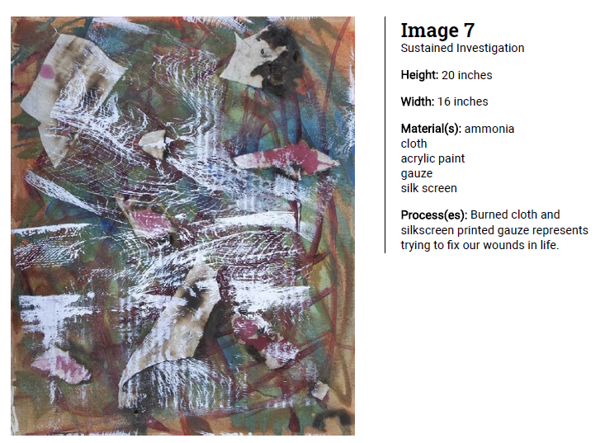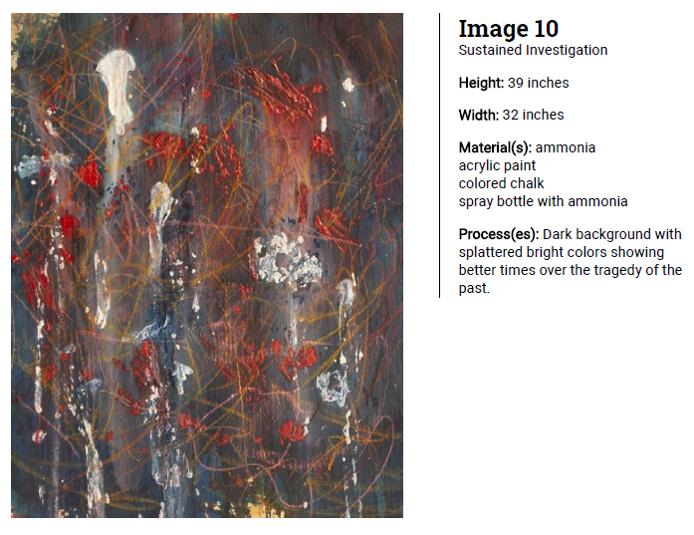
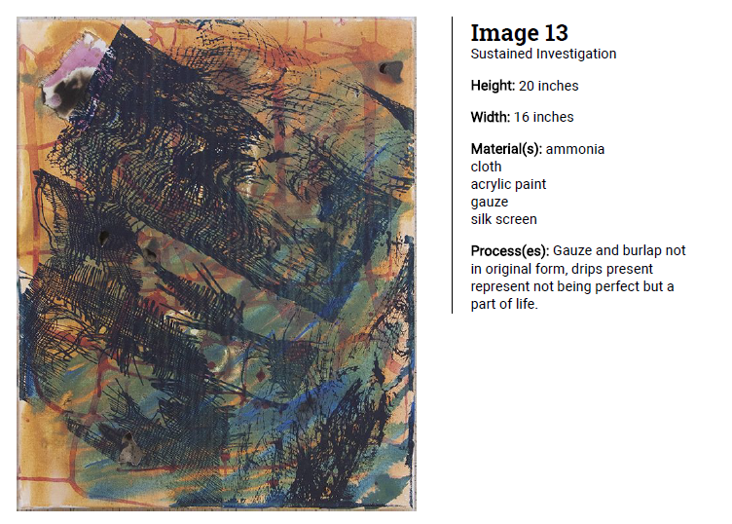
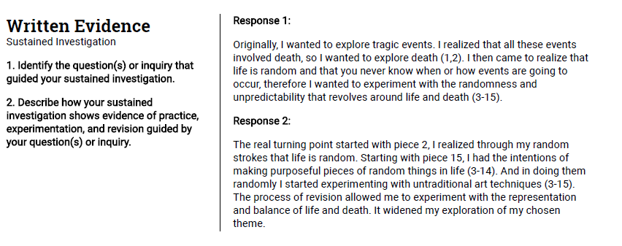

Student B
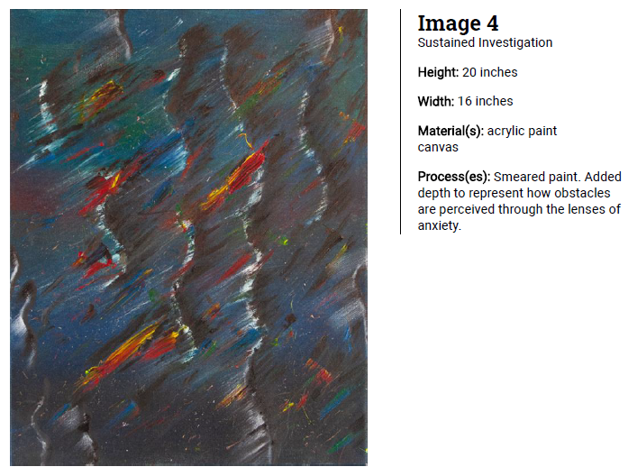
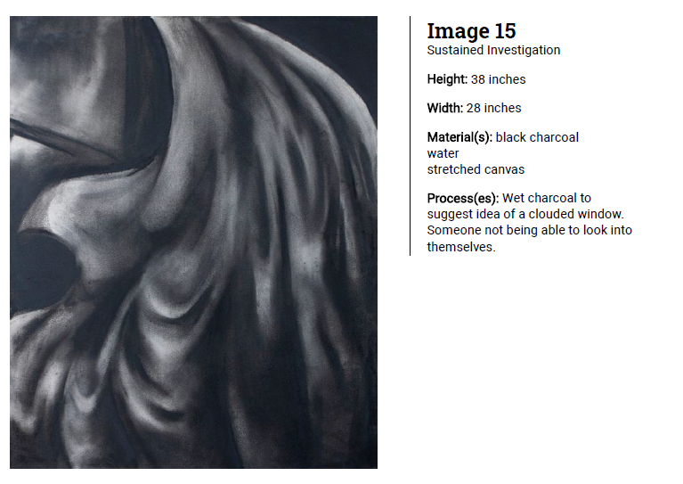
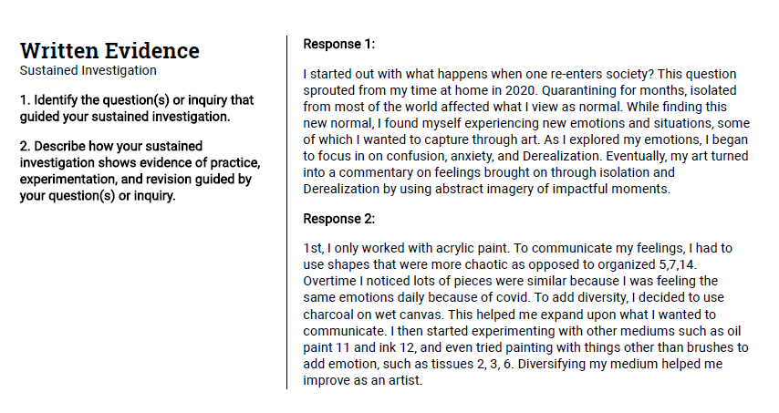
To summarize: Think of a theme
Brainstorm ideas and keep a sketchbook to document
Create 3 works of art over the summer
Write about the idea and the process in the fall

