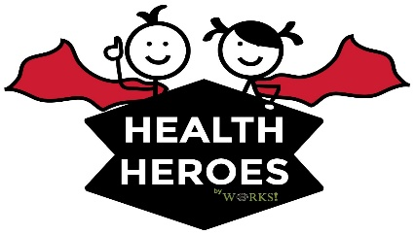

Dear Parent/Guardian,

It is our pleasure to offer on-site flu vaccinations at your student’s school on Tuesday November 9th, 2021. Flu clinics will be offered at all school locations during school hours. Health Heroes flu vaccination clinics are completely voluntary and are offered to ALL consented students, regardless of their insurance coverage.

Why get a flu vaccine?
The best way to minimize or avoid the spread of flu is to get an annual flu vaccination. Each year the vaccine protects against new strains, therefore, the vaccine should be administered annually.

Who is Health Heroes, Inc.?
At Health Heroes, we specialize in on-site vaccination clinics. Vaccines are provided at a NO-OUT-OF-POCKET expense to all students. We bill both Medicaid and private insurance; however, we never bill students or parents for any out-of-pocket expenses or deductibles. Qualifying uninsured students can be given the vaccine, free of charge. Although student participation is voluntary, these vaccinations are recommended to help keep schools healthy and cut down on high absenteeism.
What type vaccines will be given?
IIV-4 injections will be available to all consented children who do not have any contra-indicators. All vaccines given are preservative-free, mercury-free, Thimerosal-free and administered by state-licensed nurses.

What do you need to do to participate?
If you wish for your child to participate, please COMPLETELY fill out the consent form. You must include ALL insurance information, including the member ID and sign the form. If you have no insurance, please mark the appropriate box. These forms need to be returned to Greer Edwards, RN at Bishop Hartley, no later than Thursday November 4, 2021.

If you have additional questions or concerns, please contact Greer Edwards, RN at (614)27-5421, extension 10629 or Greer.Edwards@BishopHartley.org. We hope to see your child in the clinic!

Warmest regards, Warmest regards,

Brooke Harris, LPN Greer Edwards, BSN, RN
Project Manager, Ohio Bishop Hartley High School

Liberty Duke, CEO
HNH Immunizations/ Health Heroes, Inc.

